**Name:** ______________________________ **Partner’s Name:** ___________________________

Grimes Winton Borcas Cook Kowalcic Putnam Dickinson Vrcan Vidmar Laseak

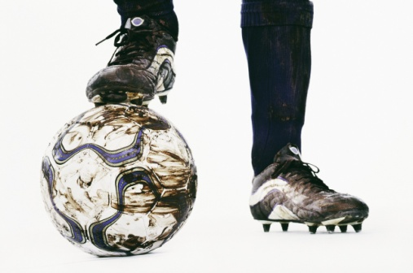

**Shooting Checklist**

___Move body to get behind ball (don’t let the ball pass!)

___Smooth movement and kick through the ball

**Dribbling Checklist**

___Control at Slow Speed

___Control at Quicker Speed

___Able to change directions without hitting other people or cones

**3**= performs the technique always

**2**= is doing a good job with the technique but could use some improvement

**1**= is not showing the technique, is out of control

Dear Coach,

**Put a star next to the skill that your partner did better with. Circle the skill that you think your partner could improve on (shooting or dribbling).**



**Now it is up to you to design a practice that will help your partner improve this skill!**

Draw a picture of what the practice may look like:

**How many minutes should your partner practice? ___________**

**OR**

**How many times should your partner practice?** (ex. 30 shots on goal) **_______________**

**How many times per week should your partner practice? ________________**

**What will it look like if your partner is improving?**

**_____________________________________________________________________________**